A

Project Activity Report

Submitted for Database Management System

(UCS-310)

TOPIC: BLOOD BANK DATABASE

MANAGEMENT SYSTEM

Submitted By:

BE Third Year, ENC5

Pratham Gupta (102015095)

Submitted To: -

Mrs. Satnam Kaur



DEPARTMENT OF COMPUTER SCIENCE and ENGINEERING THAPAR INSTITUTE OF ENGINEERING AND TECHNOLOGY,

(A DEEMED TO BE UNIVERSITY), PATIALA, PUNJAB INDIA

Jan-June 2022

INDEX

|  |  |  |
| --- | --- | --- |
| Sr. No. | Contents | Page No. |
| 1 | Problem Statement | 3 |
| 2 | ER Diagram | 4 |
| 3 | ER to Table | 8 |
| 4 | Normalization | 15 |
| 5 | SQL/PLSQL | 28 |

# Problem Statement

Patients require blood to survive operations, cancer treatments, chronic diseases, and traumatic traumas. This lifesaving care begins with a thoughtful contribution from one individual. The demand for blood is never-ending.

In 2016, 10.9 million donations were recorded, whereas in 2020, 12.7 million donations were reported, little less than expected but still sufficient despite the epidemic. As engineers, we have attempted to make the process of maintaining all records easier.

We're building a database that will keep all of the information regarding donors, recipients, blood inventories, organisations, and camps which can be used to retreive, update, and collect data.

The main benefit of having a database for blood bank administration is the quick and easy retrieval of information. Manual procedures can be eliminated.Databases help you save time and enhance the quality and consistency of your information.

# ER Diagram

ER Model stands for Entity Relationship Model is a high-level conceptual data model diagram. ER model helps to systematically analyse data requirements to produce a well-designed database. The ER Model represents real-world entities and the relationships between them. Creating an ER Model in DBMS is considered as a best practice before implementing your database.

The ER Entity Relation diagram is a visual representation of all the entities and their attributes with their relationships.

The ER diagram made for our project consists of two entities with their 18 attributes describing how the various processes and entities are related in our database.

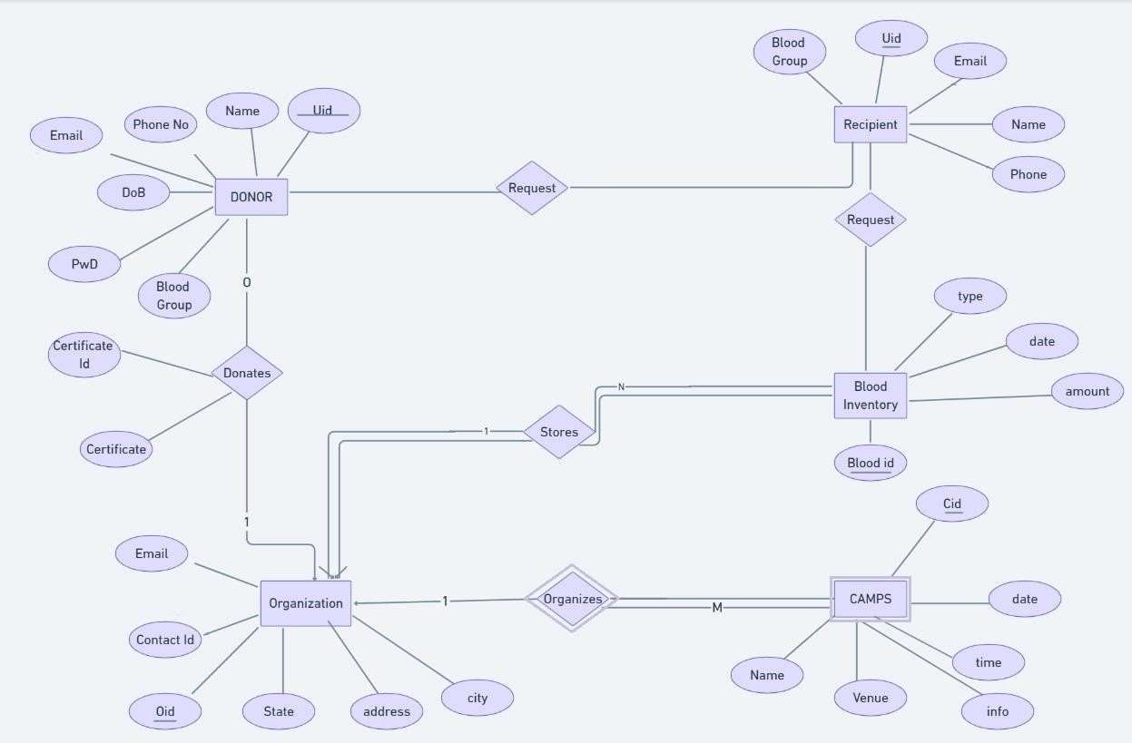

# ER-DIAGRAM DESCRIPTION

ENTITIES AND ATTRIBUTES:

Donor: Donor is the physical entity or specifically the customer who would like to provide his details for blood donation which serves the motive for our database.

Attributes associated with this entity are:

UID: The UID is a unique primary key for the donor and will be a numeric value for every customer.

Name: It is a variable string field provided for the user to provide their name.

Phone no: It is a 10-digit phone number associated with the donor.

Email: It is a varchar2 type field to store email id of the user.

DOB: It is a single value attribute to store date of birth in dd-mm-yyyy format.

Blood Group: It is a single valued varchar2 type field used for storing the blood group of donor.

PwD: It is an attribute used to store the Password of the user in encrypted format.

Donor entity can be associated with ‘donates’ and ‘request’ processes directly.

Organisation: This is a physical entity related to donor and blood inventory directly by many to many relationship. The donor and organization both participate partially in this relation. The attributes of this entities are explained further.

Attributes of the entity mentioned are:

Email: It is a varchar2 type field to store email id.

State: It is a single valued field that stores a valid state name as a part of their address.

Address: It is a single valued field that stores local/ regional address of the user.

City: It is a single valued field that stores valid city name for the organization.

Contact ID: It is a field which identifies the donor and receiver individually.

OID: Organization ID a single valued key to uniquely identify an organization.

Donation: This is a relationship between two entities, ‘Donor’ and ‘Organisation’.

Its attributes are:

Certificate ID: This is a unique certificate ID when they donate blood.

Certificate: This refers to the certificate issued by the organisation for the global cause of donating blood.

Recipient: This is a physical entity which provides the details of the recipients of blood and is related to ‘donor’ entity by the relation ‘request’ and also ‘requests’ blood from the ‘blood inventory’ entity. Attributes associated with this entity are:

UID: The UID is a primary key for the recipient and will be a numeric value for every customer.

Blood Group: It is an attribute which will tell about the blood group needed by the recipient and will be a string.

Email: It is a string storing the email addresses of the recipients.

Name: It is the attribute containing the names of all the recipients of string type.

Phone: It is an attribute storing the phone no. of recipients and is of type number.

Blood inventory: This is a physical entity related to ‘Organization’ entity by many to many relationships of ‘stores’ as it stores all the information about the blood donors and to ‘recipient’ by the relation ‘request’. The relationship between blood inventory and organisation is having total participation from both sides.

Attributes associated with this entity are:

Blood id: It is a primary key attribute which is a number and is given to each donor uniquely.

Type: It is a string attribute for storing the blood type stored.

Amount: It is a number attribute storing the price of blood.

Date: It is a single valued attribute of ‘date’ type.

Camps: This is a physical entity related to ‘Organization’ entity by many to one relationship of ‘stores’ as it stores all the information about the camps organized by various organisations. The relationship between camps and organisation is having total participation and partial participation respectively. It is a case of weak relationship with camps being the weak entity.

Attributes associated with this entity are

Cid: It is the primary key of weak entity named camps. It stores a numeric value that can uniquely identify each camp.

Name: It is a single valued attribute that can store the name of each camp in string format(varchar).

Date: It is a single valued attribute of ‘date’ type.

Time: It is a single valued attribute of ‘time’ type.

Venue: It denotes the location of the camp organized and stores it in varchar format.

Info: It stores some miscellaneous information about the camp in varchar format.

# ER to Table

Creating tables

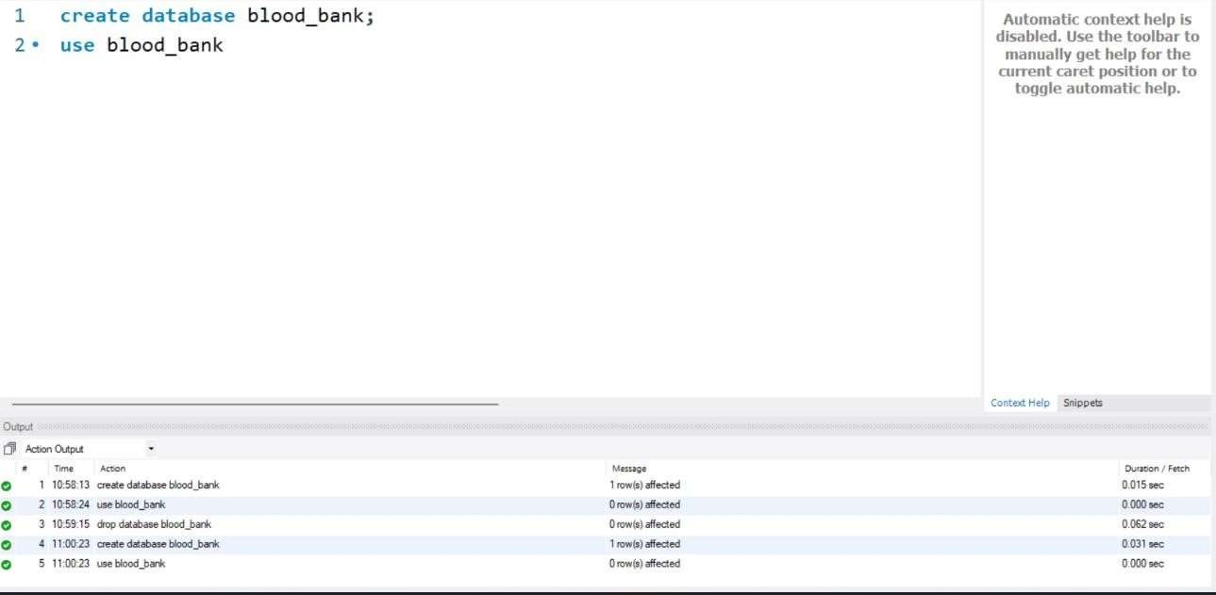 create table donor( uid int, name varchar(20), phone_no bigint(10), email varchar(20), DOB date, pwd varchar(30), blood_group varchar(5), primary key (uid) );

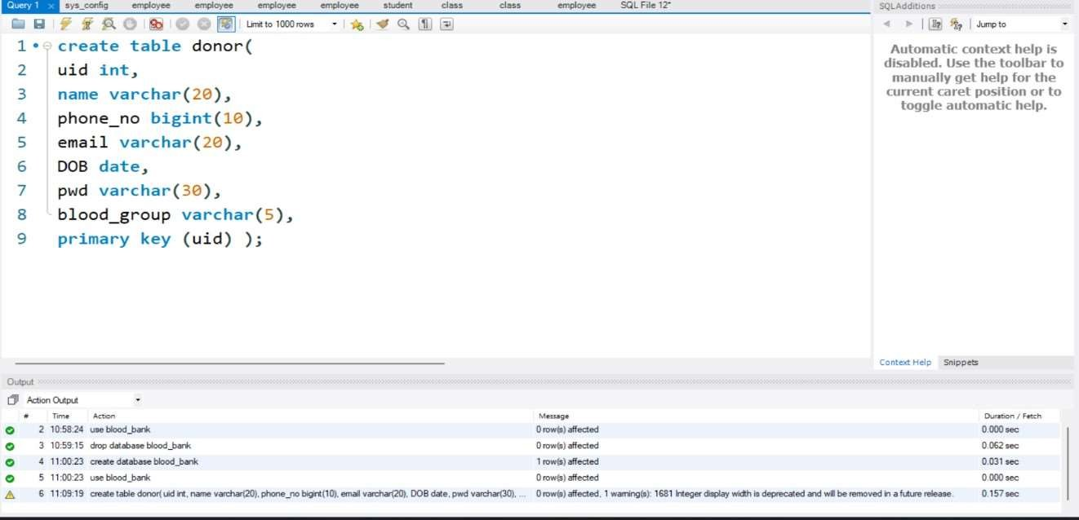 create table recipient(

uid int primary key, name varchar(20), phone_no bigint(10), email varchar(20), blood_group(5)

);

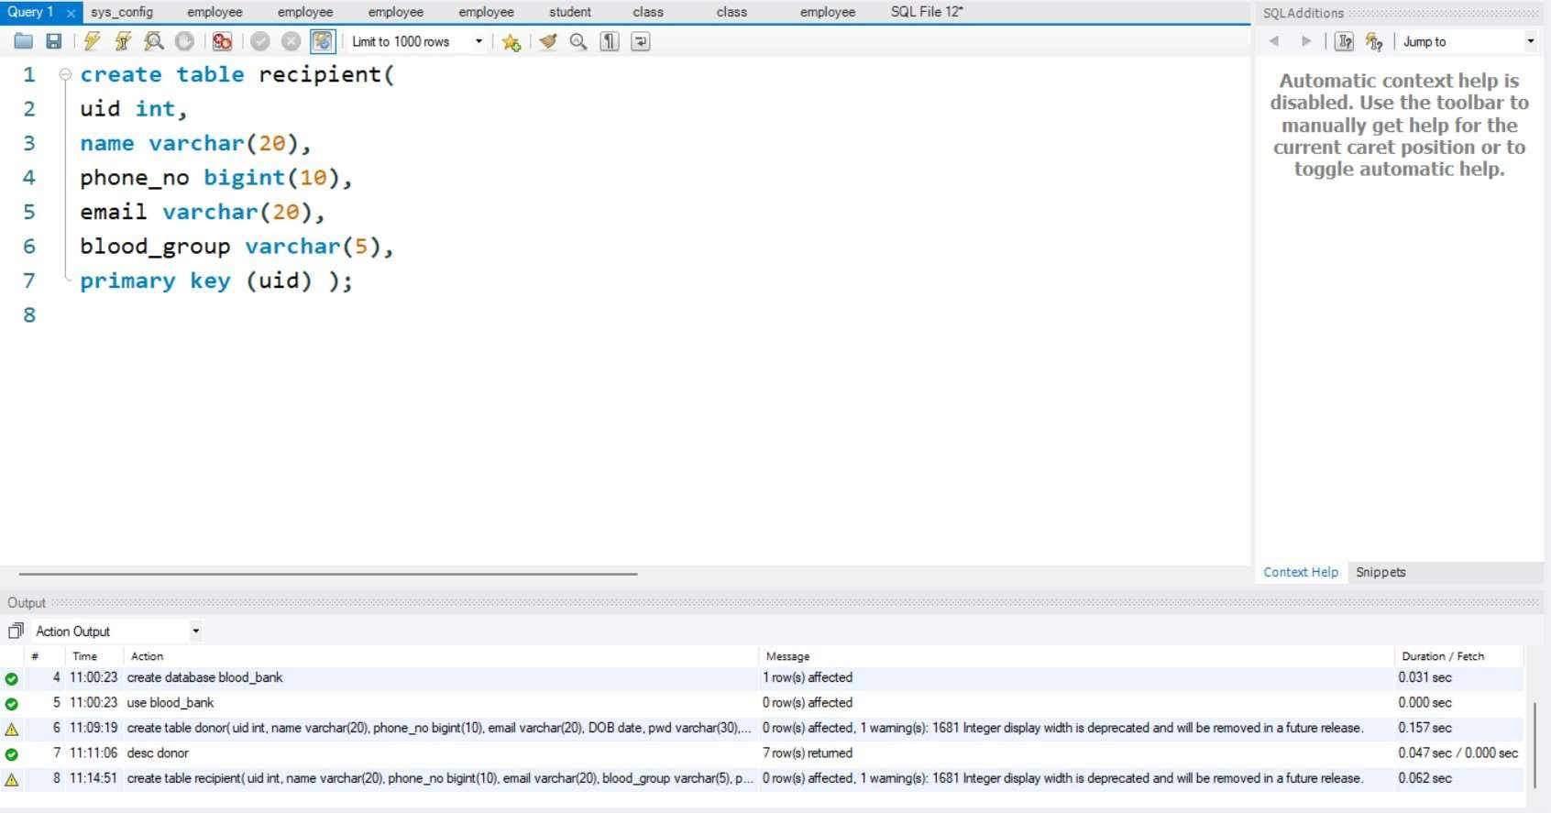

create table request( uid1 int, uid2 int,

foreign key (uid1) references donor(uid), foreign key (uid2) references

recipient(uid) );

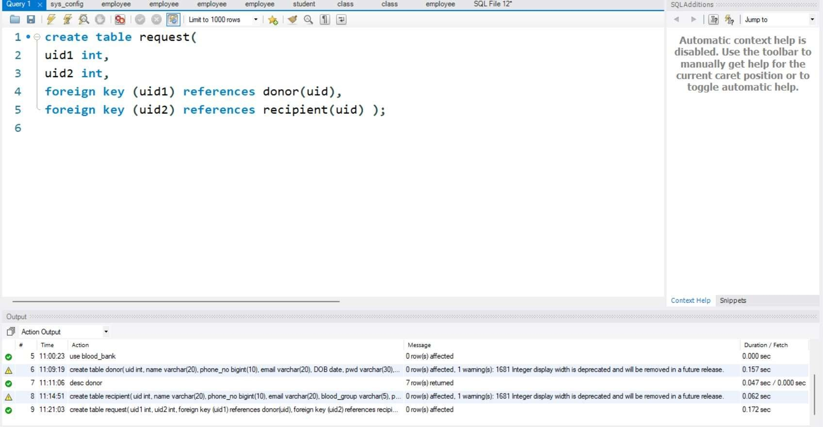

create table organisation( oid int,

contact_id bigint(10), email varchar(20), state varchar(20), address varchar(50), city varchar(20), primary key (oid) );

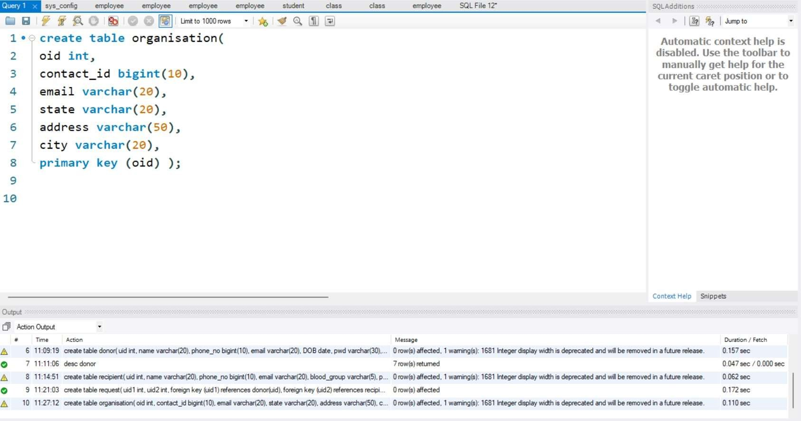 create table donation( certificate_id bigint(4), uid int primary key, name varchar(30), phone_no bigint(10), email varchar(20), DOB date, pwd varchar(30), blood_group varchar(5),

oid1 int,

foreign key (oid1) references organisation(oid) );

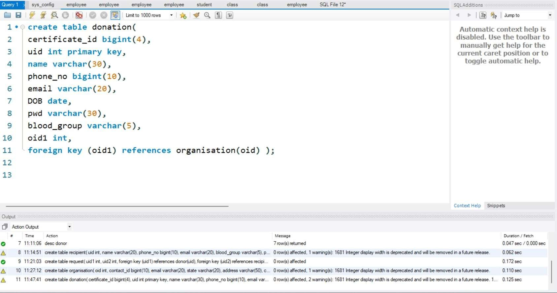

create table organizes(

oid1 int, cid int primary key, date1 date, timer time, info varchar(30), venue varchar(30), name varchar(30),

foreign key (oid1) references organisation(oid) );

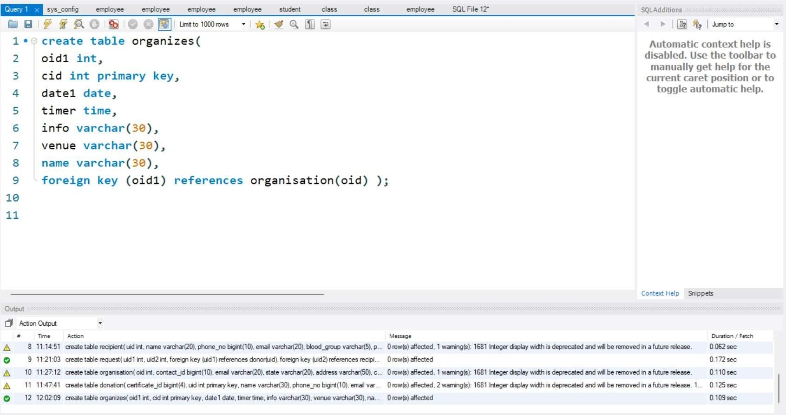

create table inventory( oid1 int,

bloodid int primary key,

btype varchar(5), date1 date, amount int foreign key (oid1) references organisation(oid));

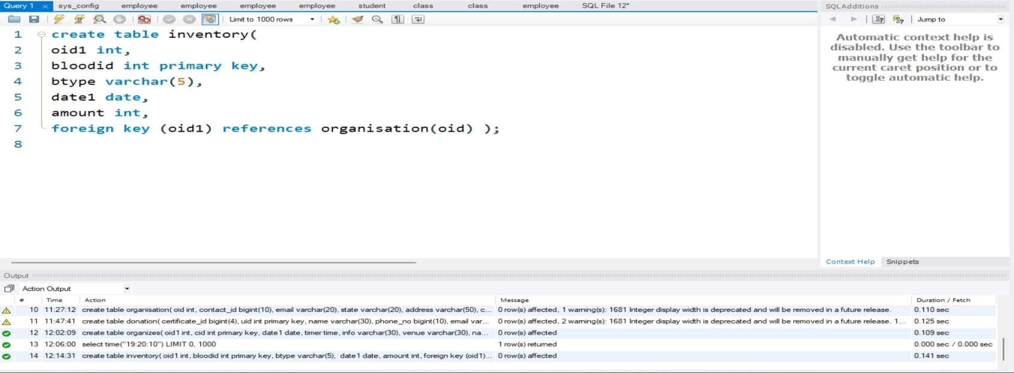

create table blood( bloodid int primary key, btype varchar(5), date1 date, amount int

);

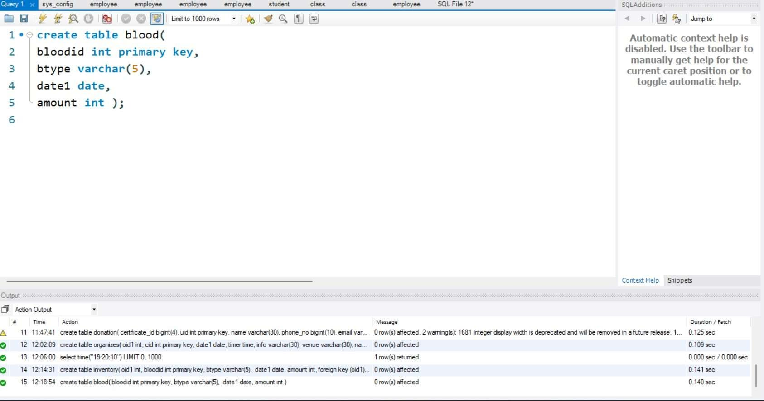

create table recipient1(

bloodgroup varchar(5), uid int primary key, email varchar(30), name varchar(20), phone bigint(10), bid1

int,

foreign key(bid1) references blood(bloodid));

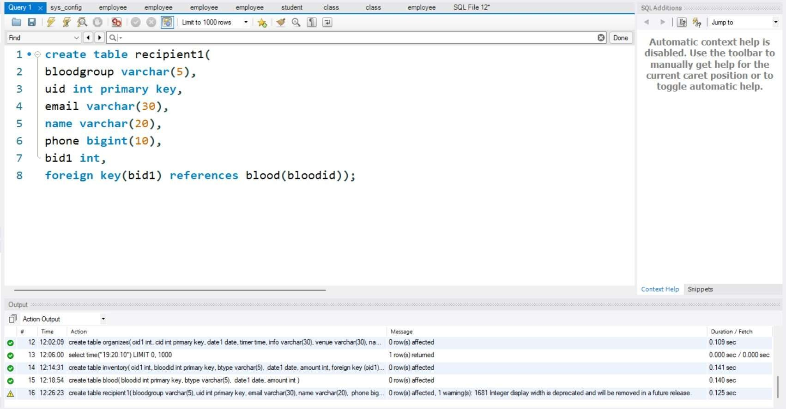

# Normalization

1NF/First Normal Form

A table is said to be in first normal form id there are no multiple values for a cell in a table. The tables used in our project such as

DONOR, DONATIONS and so on are in first normal form as they do not accept multiple values of an attribute per tuple.

The fields such as Email, Phone number can have multiple values per tuple so either multiple columns such as phone1, phone2 were to be provided or decomposition was to be done which was preferred.

2NF/Second Normal Form

This normal form states that partial functional dependencies cannot exist. To keep tables in second normal form, primary keys assigned have only one attribute in case of each table.

We have primary keys such as UID, OID etc which consist of only one attribute which solves the problem of partial functional dependency.

3NF/ Third Normal Form

Third normal form states that transitive functional dependencies cannot exist.

The 5 entities in our ER diagram are decomposed into 9 tables including tables for relationships. This is done in order to separate attributes into multiple tables such that no transitive relationship exists.

# Inserting Values

insert into donor values(0001,'Ram',9898989898,'1@gmailcom','2001-01-01','xyzabc','b+'); insert into donor values(0002,'Ama',9898989898,'2@gmailcom','2001-01-02','xyzabc','A+'); insert into donor values(0003,'jili',9898989898,'3@gmailcom','2001-01-03','xyzabc','o+'); insert into donor values(0004,'Juli',9898989898,'4@gmailcom','2001-01-04','xyzabc','A+'); insert into donor values(0005,'aka',9898989898,'5@gmailcom','2001-01-05','xyzabc','B+'); insert into donor values(0006,'baka',9898989898,'6@gmailcom','2001-01-06','xyzabc','C+'); insert into donor values(0007,'daka',9898989898,'7@gmailcom','2001-01-07','xyzabc','A+'); insert into donor values(0008,'sid',9898989898,'8@gmailcom','2001-01-10','xyzabc','B+'); insert into donor values(0009,'mid',9898989898,'9@gmailcom','2001-01-11','xyzabc','C+'); insert into donor values(0010,'rewa',9898989898,'10@gmailcom','2001-01-12','xyzabc','B+'); insert into donor values(0011,'raywa',9898989898,'11@gmailcom','2001-01-13','xyzabc','AB+'); insert into donor values(0012,'rahwa',9898989898,'12@gmailcom','2001-01-14','xyzabc','O-'); insert into donor values(0013,'gourab',9898989898,'13@gmailcom','2001-01-15','xyzabc','A+'); insert into donor values(0014,'Gaurav',9898989898,'14@gmailcom','2001-01-16','xyzabc','b+'); insert into donor values(0015,'Kasis',9898989898,'15@gmailcom','2001-01-17','xyzabc','AB-'); insert into donor values(0016,'Kosis',9898989898,'16@gmailcom','2001-01-18','xyzabc','A-'); insert into donor values(0017,'kasol',9898989898,'17@gmailcom','2001-01-19','xyzabc','B+'); insert into donor values(0018,'Bani',9898989898,'18@gmailcom','2001-01-20','xyzabc','AB+'); insert into donor values(0019,'Banno',9898989898,'19@gmailcom','2001-01-21','xyzabc','B-'); insert into donor values(0021,'Rama',9898949898,'1@gmailcom','2001-01-01','xyzfbc','b+'); insert into donor values(0022,'Amaa',9898949898,'2@gmailcom','2001-01-02','xyzfbc','A+'); insert into donor values(0023,'jilia',9898289898,'3@gmailcom','2001-01-03','xyfabc','o+'); insert into donor values(0024,'Julia',9898589898,'4@gmailcom','2001-01-04','xyfabc','A+'); insert into donor values(0025,'akaa',9898969898,'5@gmailcom','2001-01-05','xyfabc','B+'); insert into donor values(0026,'bakaa',9898589898,'6@gmailcom','2001-01-06','xfzabc','C+'); insert into donor values(0027,'dakaa',9898889898,'7@gmailcom','2001-01-07','xyzafc','A+'); insert into donor values(0028,'sida',9898979898,'8@gmailcom','2001-01-10','xyzabf','B+'); insert into donor values(0029,'mida',9898959898,'9@gmailcom','2001-01-11','xyzafc','C+'); insert into donor values(0020,'rewaa',9898389898,'10@gmailcom','2001-01-12','xyzfbc','B+'); insert into donor values(0021,'raywaa',9891989898,'11@gmailcom','2001-01-13','xyfabc','AB+'); insert into donor values(0022,'rahwaa',9891989898,'12@gmailcom','2001-01-14','xyfabc','O-'); insert into donor values(0023,'gouraba',9838989898,'13@gmailcom','2001-01-15','xyzzbc','A+'); insert into donor values(0024,'Gaurava',9848989898,'14@gmailcom','2001-01-

16','xyzabc','b+'); insert into donor values(0025,'Kasisa',9898589898,'15@gmailcom','2001-01-

17','xyzabv','AB-'); insert into donor values(0026,'Kosisa',9898589898,'16@gmailcom','2001-

01-18','xyzabn','A-'); insert into donor values(0027,'kasola',9898589898,'17@gmailcom','2001-

01-19','xyzabn','B+'); insert into donor values(0028,'Bania',9898979898,'18@gmailcom','2001-

01-20','xyzabm','AB+'); insert into donor values(0029,'Bannoa',9898969898,'19@gmailcom','2001-01-21','xyzaic','B-');

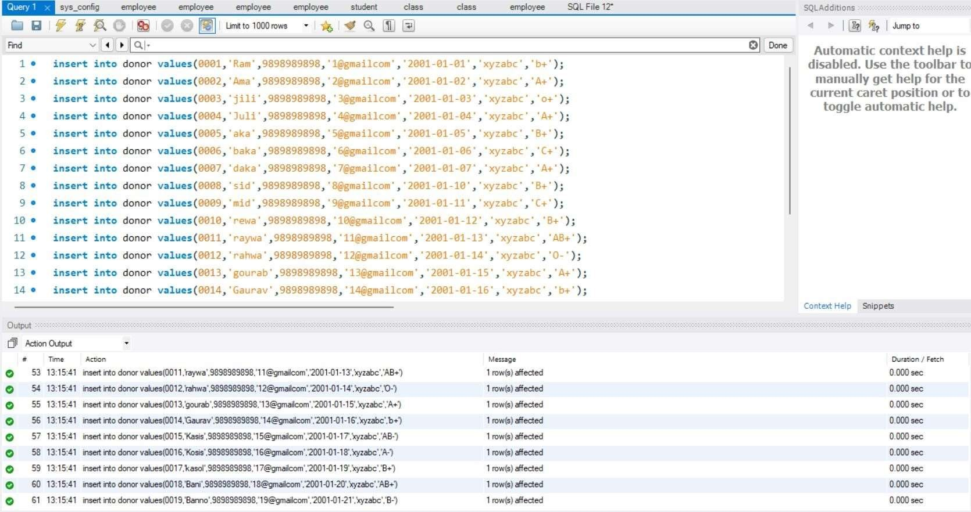

RECIPIENT:

insert into recipient values(0002,'KAma',9898989898,'2@gmailcom','A+'); insert into recipient values(0001,'KRam',9898189898,'1@gmailcom','b+'); insert into recipient values(0003,'Kjili',9892989898,'3@gmailcom','o+'); insert into recipient values(0004,'KJuli',9892989898,'4@gmailcom','A+'); insert into recipient values(0005,'Kaka',9898289898,'5@gmailcom','B+'); insert into recipient values(0006,'kbaka',9892989898,'6@gmailcom','C+'); insert into recipient values(0007,'kdaka',9893989898,'7@gmailcom','A+'); insert into recipient values(0008,'ksid',9898984898,'8@gmailcom','B+'); insert into recipient values(0009,'kmid',9898989898,'9@gmailcom','C+'); insert into recipient values(0010,'krewa',9898939898,'10@gmailcom','B+'); insert into recipient values(0011,'kraywa',9898389898,'11@gmailcom','AB+'); insert into recipient values(0012,'krahwa',9898389898,'12@gmailcom','O-'); insert into recipient values(0013,'kgourab',9893989898,'13@gmailcom','A+'); insert into recipient values(0014,'kGaurav',98983989898,'14@gmailcom','b+'); insert into recipient values(0016,'kKosis',9898939898,'16@gmailcom','A-'); insert into recipient values(0015,'kKasis',9898939898,'15@gmailcom','AB-'); insert into recipient values(0017,'kkasol',9898989898,'17@gmailcom','B+'); insert into recipient values(0018,'kBani',9198989898,'18@gmailcom','AB+'); insert into recipient values(0019,'kBanno',9298989898,'19@gmailcom','B-'); insert into recipient values(0021,'kRama',9198949898,'1@gmailcom','b+'); insert into recipient values(0022,'kAmaa',9298949898,'2@gmailcom','A+'); insert into recipient values(0023,'kjilia',9398289898,'3@gmailcom','o+'); insert into recipient values(0024,'kJulia',9498589898,'4@gmailcom','A+'); insert into recipient values(0025,'kakaa',9818969898,'5@gmailcom','B+'); insert into recipient values(0026,'kbakaa',9198589898,'6@gmailcom','C+'); insert into recipient values(0027,'kdkakaa',9198889898,'7@gmailcom','A+'); insert into recipient values(0028,'kskida',9818979898,'8@gmailcom','B+'); insert into recipient values(0029,'kmida',9891959898,'9@gmailcom','C+'); insert into recipient values(0020,'krewaa',9818389898,'10@gmailcom','B+'); insert into recipient values(0021,'kraywaa',9811989898,'11@gmailcom','AB+'); insert into recipient values(0022,'krahwaa',9891989898,'12@gmailcom','O-'); insert into recipient values(0023,'kgouraba',9818989898,'13@gmailcom','A+'); insert into recipient values(0024,'kGaurava',9818989898,'14@gmailcom','b+'); insert into recipient values(0025,'kKasisa',9891589898,'15@gmailcom','AB-'); insert into recipient values(0026,'kKosisa',9891589898,'16@gmailcom','A-'); insert into recipient values(0027,'kasola',9198589898,'17@gmailcom','B+'); insert into recipient values(0028,'kBania',9198979898,'18@gmailcom','AB+'); insert into recipient values(0029,'kBannoa',9198969898,'19@gmailcom','B-');

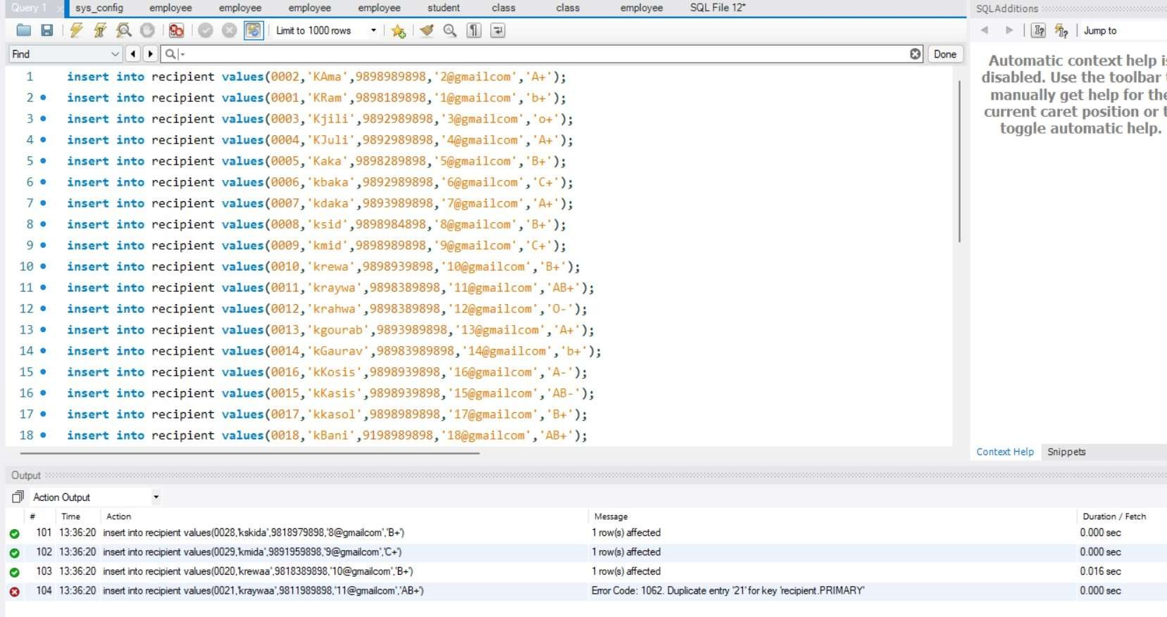

REQUEST:

insert into request values(0002,0001); insert into request values(0001,0002); insert into request values(0003,0003); insert into request values(0004,0004); insert into request values(0005,0005); insert into request values(0006,0006); insert into request values(0007,0007); insert into request values(0008,0008); insert into request values(0009,0009); insert into request values(0010,0010); insert into request values(0011,0011); insert into request values(0012,0012); insert into request values(0013,0013); insert into request values(0014,0014); insert into request values(0016,0015); insert into request values(0015,0016); insert into request values(0017,0017); insert into request values(0018,0018); insert into request values(0019,0019); insert into request values(0021,0021); insert into request values(0022,0022); insert into request values(0023,0023); insert into request values(0024,0024); insert into request values(0025,0025); insert into request values(0026,0026); insert into request values(0027,0027); insert into request values(0028,0028); insert into request values(0029,0029);

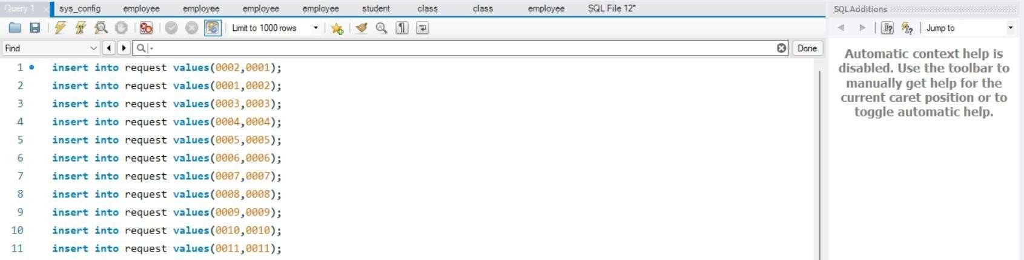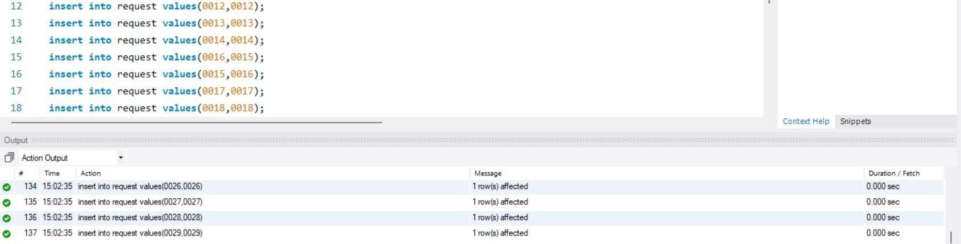

ORGANISATION:

insert into organisation values(1111,9898989898,'org1@gmail.com','Punjab','TIET','Patiala'); insert into organisation values(1112,9898989898,'org2@gmail.com','Punjab','Abc road','Ludhiana'); insert into organisation values(1113,1898989898,'org3@gmail.com','Punjab','BT NAGAR','Amritsar'); insert into organisation values(1114,9298989898,'org4@gmail.com','Punjab','RP ROAD','Bhatinda');

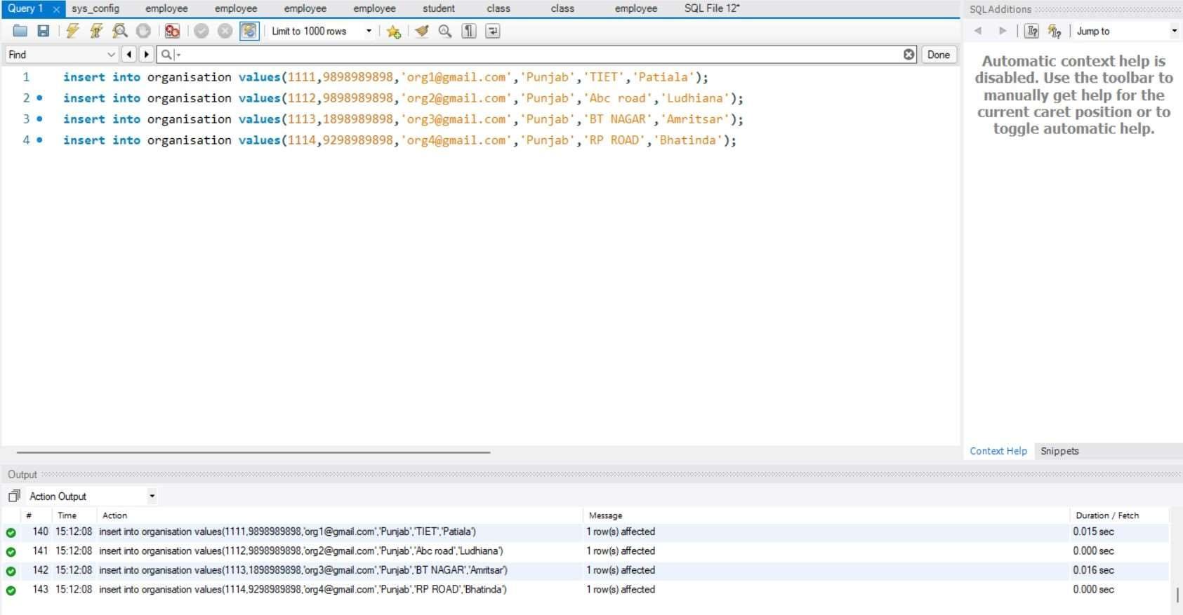

DONATION:

insert into donation values(10,0010,'rewa',9898989898,'10@gmailcom','2001-01-

12','xyzabc','B+',1111);

insert into donation values(11,0011,'raywa',9898989898,'11@gmailcom','2001-01-

13','xyzabc','AB+',1112);

insert into donation values(12,0012,'rahwa',9898989898,'12@gmailcom','2001-01-14','xyzabc','O-

',1113);

insert into donation values(13,0013,'gourab',9898989898,'13@gmailcom','2001-01-

15','xyzabc','A+',1114);

insert into donation values(14,0014,'Gaurav',9898989898,'14@gmailcom','2001-01-

16','xyzabc','b+',1111);

insert into donation values(15,0015,'Kasis',9898989898,'15@gmailcom','2001-01-17','xyzabc','AB-

',1112);

insert into donation values(16,0016,'Kosis',9898989898,'16@gmailcom','2001-01-18','xyzabc','A-

',1113);

insert into donation values(17,0017,'kasol',9898989898,'17@gmailcom','2001-

0119','xyzabc','B+',1114);

insert into donation values(18,0018,'Bani',9898989898,'18@gmailcom','2001-01-

20','xyzabc','AB+',1111);

insert into donation values(19,0019,'Banno',9898989898,'19@gmailcom','2001-01-21','xyzabc','B-

',1112);

insert into donation values(20,0021,'Rama',9898949898,'1@gmailcom','2001-01-

01','xyzfbc','b+',1113);

insert into donation values(21,0022,'Amaa',9898949898,'2@gmailcom','2001-01- 02','xyzfbc','A+',1114);

insert into donation values(22,0023,'jilia',9898289898,'3@gmailcom','2001-01-

03','xyfabc','o+',1111);

insert into donation values(23,0024,'Julia',9898589898,'4@gmailcom','2001-01-

04','xyfabc','A+',1112);

insert into donation values(24,0025,'akaa',9898969898,'5@gmailcom','2001-01-

05','xyfabc','B+',1113);

insert into donation values(25,0026,'bakaa',9898589898,'6@gmailcom','2001-01-

06','xfzabc','C+',1114);

insert into donation values(26,0027,'dakaa',9898889898,'7@gmailcom','2001-01-

07','xyzafc','A+',1111);

insert into donation values(27,0028,'sida',9898979898,'8@gmailcom','2001-01-

10','xyzabf','B+',1112);

insert into donation values(28,0029,'mida',9898959898,'9@gmailcom','20010111','xyzafc','C+',1113);

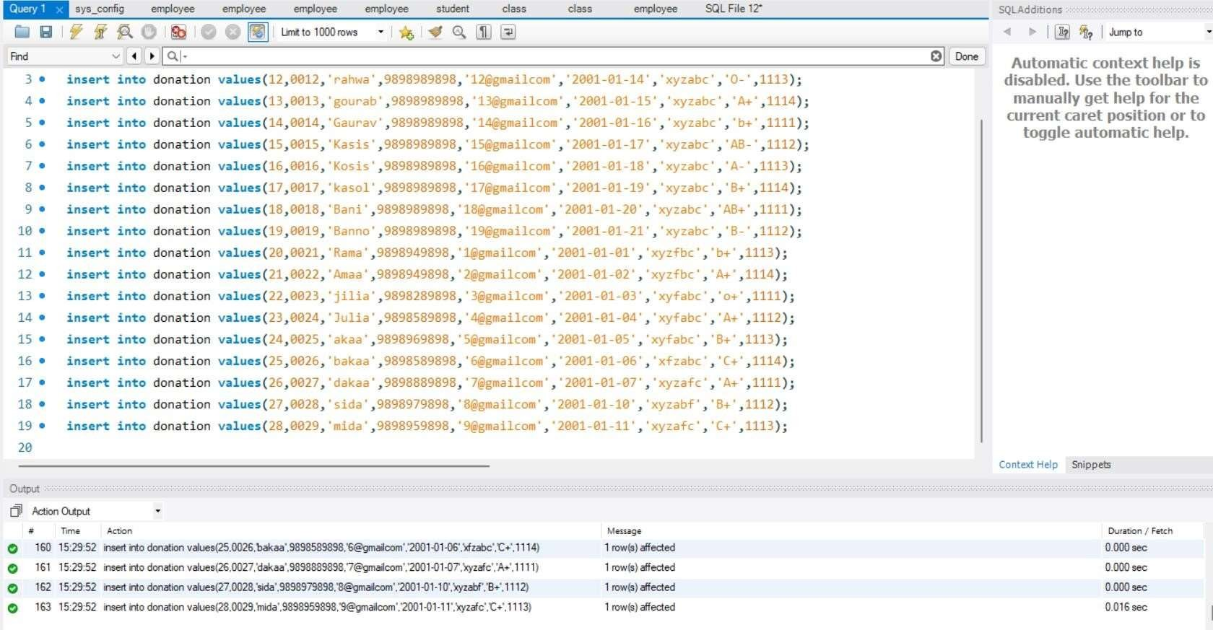

ORGANIZES:

insert into organizes values(1111,21,'2022-01-10','10:00:00','weekly blood donation camp','abc Chowk','camp1');

insert into organizes values(1112,31,'2022-02-09','11:00:00','monthly blood donation camp','abc Chowk','camp2');

insert into organizes values(1113,40,'2022-03-08','12:00:00','weekly blood donation camp','ab

road','camp3');

insert into organizes values(1114,50,'2022-04-07','13:00:00','quarterly blood donation

camp','aadarsh nagar','camp4');

insert into organizes values(1111,22,'2022-05-06','14:00:00','weekly blood donation camp','rc colony','camp5');

insert into organizes values(1112,32,'2022-06-05','14:00:00','monthly blood donation camp','op road','camp6');

insert into organizes values(1113,41,'2022-07-04','11:00:00','weekly blood donation camp','nabha

road','camp7');

insert into organizes values(1114,51,'2022-08-03','12:00:00','yearly blood donation camp','tiet road','camp8');

insert into organizes values(1111,23,'2022-09-02','13:00:00','weekly blood donation camp','a

colony','camp9');

insert into organizes values(1112,33,'2022-10-01','14:00:00','monthly blood donation camp','akas

homes','camp10');

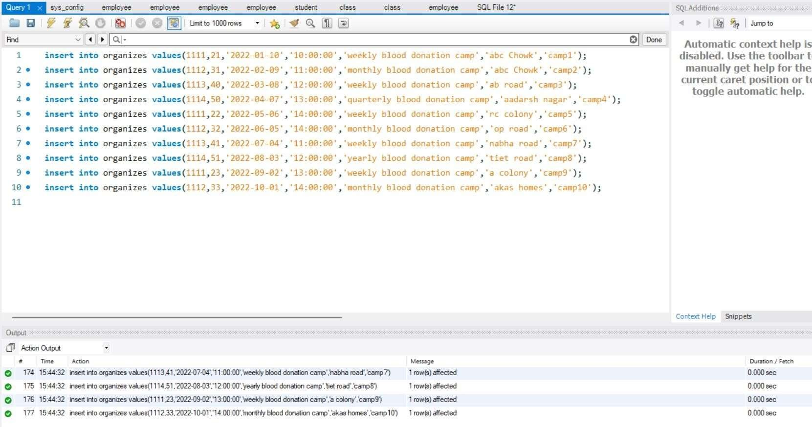

INVENTORY:

insert into inventory values(1111,100,'B+','2021-05-01',2); insert into inventory values(1112,101,'AB+','2021-05-04',1); insert into inventory values(1113,102,'AB-','2021-05-06',1); insert into inventory values(1114,103,'b+','2021-03-01',1); insert into inventory values(1111,104,'AB-','2021-05-10',1); insert into inventory values(1112,105,'b+','2021-03-01',2); insert into inventory values(1113,106,'b+','2021-05-20',2); insert into inventory values(1114,107,'b-','2021-05-01',2); insert into inventory values(1111,108,'AB+','2021-02-01',1); insert into inventory values(1112,109,'o-','2021-05-30',1); insert into inventory values(1113,110,'b+','2021-02-03',2); insert into inventory values(1114,111,'AB-','2021-04-25',1); insert into inventory values(1111,112,'b+','2021-05-11',2); insert into inventory values(1112,113,'o+','2021-05-01',1); insert into inventory values(1113,114,'b+-','2021-05-12',1); insert into inventory values(1114,115,'o+','2021-06-13',2); insert into inventory values(1111,116,'AB+','2021-05-01',1); insert into inventory values(1112,117,'o+','2021-03-01',2); insert into inventory values(1113,118,'b-','2021-05-16',1); insert into inventory values(1114,119,'AB+','2021-05-01',1); insert into inventory values(1111,120,'o-','2021-02-20',2); insert into inventory values(1112,121,'b+','2021-05-01',1); insert into inventory values(1113,122,'b-','2021-02-11',1); insert into inventory values(1114,123,'AB+','2021-05-01',1); insert into inventory values(1111,124,'o+','2021-05-13',1); insert into inventory values(1112,125,'b+','2021-03-22',2); insert into inventory values(1113,126,'o-','2021-05-23',1); insert into inventory values(1114,127,'AB+','2021-04-08',1); insert into inventory values(1111,128,'o-','2021-05-09',1);

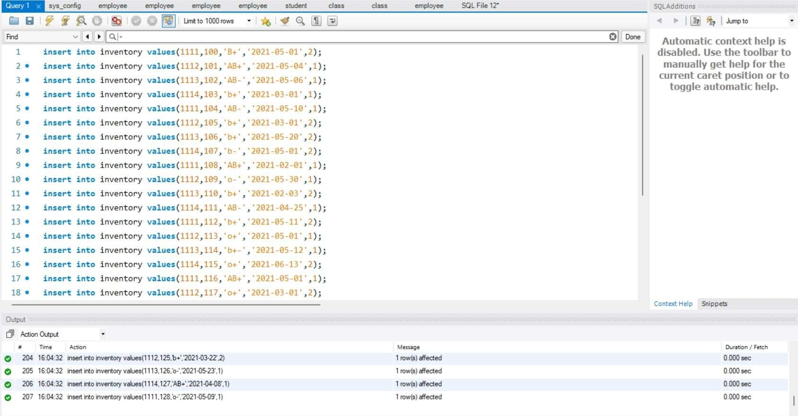

BLOOD:

insert into blood values(100,'B+','2021-05-01',2); insert into blood values(101,'AB+','2021-05-04',1); insert into blood values(102,'AB-','2021-05-06',1); insert into blood values(103,'b+','2021-03-01',1); insert into blood values(104,'AB-','2021-05-10',1); insert into blood values(105,'b+','2021-03-01',2); insert into blood values(106,'b+','2021-05-20',2); insert into blood values(107,'b-','2021-05-01',2); insert into blood values(108,'AB+','2021-02-01',1); insert into blood values(109,'o-','2021-05-30',1); insert into blood values(110,'b+','2021-02-03',2); insert into blood values(111,'AB-','2021-04-25',1); insert into blood values(112,'b+','2021-05-11',2); insert into blood values(113,'o+','2021-05-01',1); insert into blood values(114,'b+-','2021-05-12',1); insert into blood values(115,'o+','2021-06-13',2); insert into blood values(116,'AB+','2021-05-01',1); insert into blood values(117,'o+','2021-03-01',2); insert into blood values(118,'b-','2021-05-16',1); insert into blood values(119,'AB+','2021-05-01',1); insert into blood values(120,'o-','2021-02-20',2); insert into blood values(121,'b+','2021-05-01',1); insert into blood values(122,'b-','2021-02-11',1); insert into blood values(123,'AB+','2021-05-01',1); insert into blood values(124,'o+','2021-05-13',1);

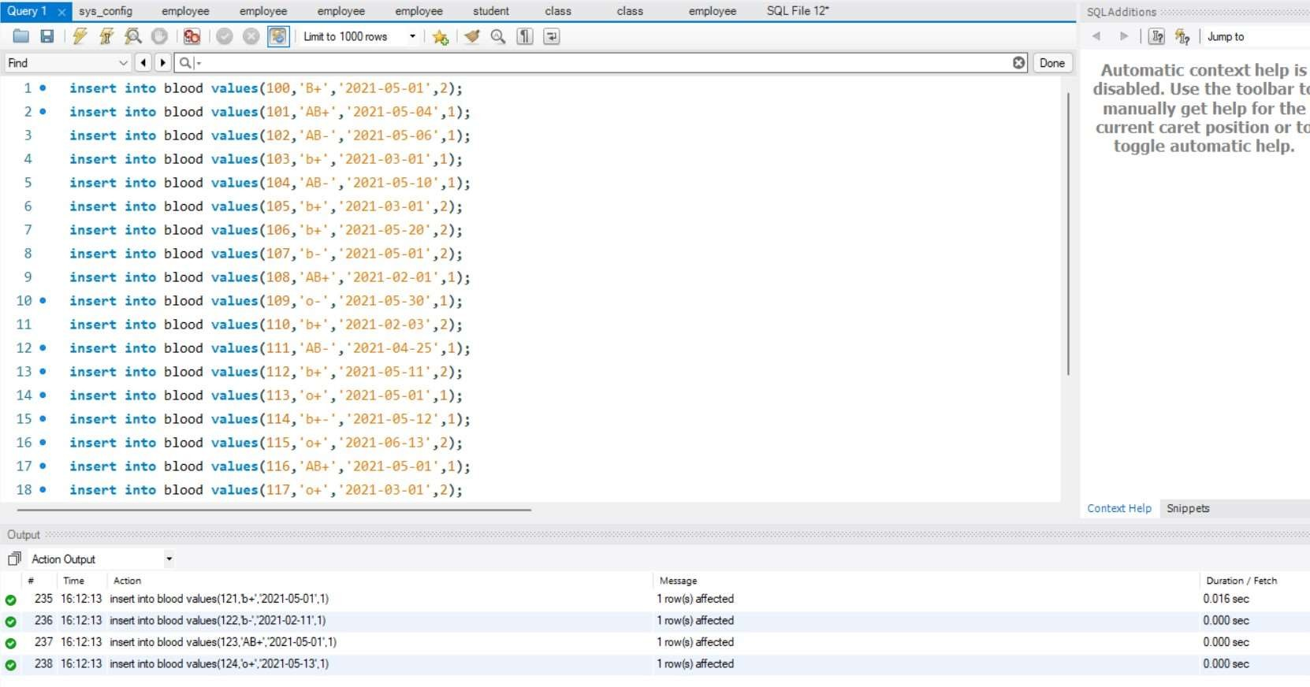

RECEPIENT1 insert into recipient1 values('A+',1001,'1@gmail.com','ram',6565656565,100); insert into recipient1 values('O+',1002,'2@gmail.com','Shayam',6565656565,101); insert into recipient1 values('AB+',1003,'3@gmail.com','Shyama',6565656565,102); insert into recipient1 values('A+',1004,'4@gmail.com','rama',6565656565,103); insert into recipient1 values('B+',1005,'5@gmail.com','Harsh',6565656565,104); insert into recipient1 values('O+',1006,'6@gmail.com','Harsha',6565636565,105); insert into recipient1 values('AO+',1007,'7@gmail.com','Hari',6565616565,106); insert into recipient1 values('AB+',1008,'8@gmail.com','Haria',6562656565,107); insert into recipient1 values('A+',1009,'9@gmail.com','Rahul',6565656565,108); insert into recipient1 values('AB+',1010,'10@gmail.com','Rohit',6565656565,109); insert into recipient1 values('B+',1011,'11@gmail.com','Raghav',6565656165,110); insert into recipient1 values('O+',1012,'12@gmail.com','Ram',6565656561,111); insert into recipient1 values('AB+',1013,'13@gmail.com','Rohit',6565651565,112); insert into recipient1 values('O+',1014,'14@gmail.com','Raman',6565651565,113); insert into recipient1 values('AO+',1015,'15@gmail.com','Gaurav',6561656565,114); insert into recipient1 values('AO+',1016,'16@gmail.com','Anamik',6562656565,115); insert into recipient1 values('BA+',1017,'17@gmail.com','Ana',6565656265,116); insert into recipient1 values('B+',1018,'18@gmail.com','Aman',6565656365,117); insert into recipient1 values('B+',1020,'19@gmail.com','Amanik',6565456565,118); insert into recipient1 values('B+',1021,'20@gmail.com','Ram',6565456565,119); insert into recipient1 values('B+',1022,'21@gmail.com','ram',6515656565,120); insert into recipient1 values('B+',1023,'22@gmail.com','ram',6265656565,121); insert into recipient1 values('B+',1024,'23@gmail.com','ram',6565636565,122); insert into recipient1 values('B+',1025,'24@gmail.com','ram',6565636565,123);

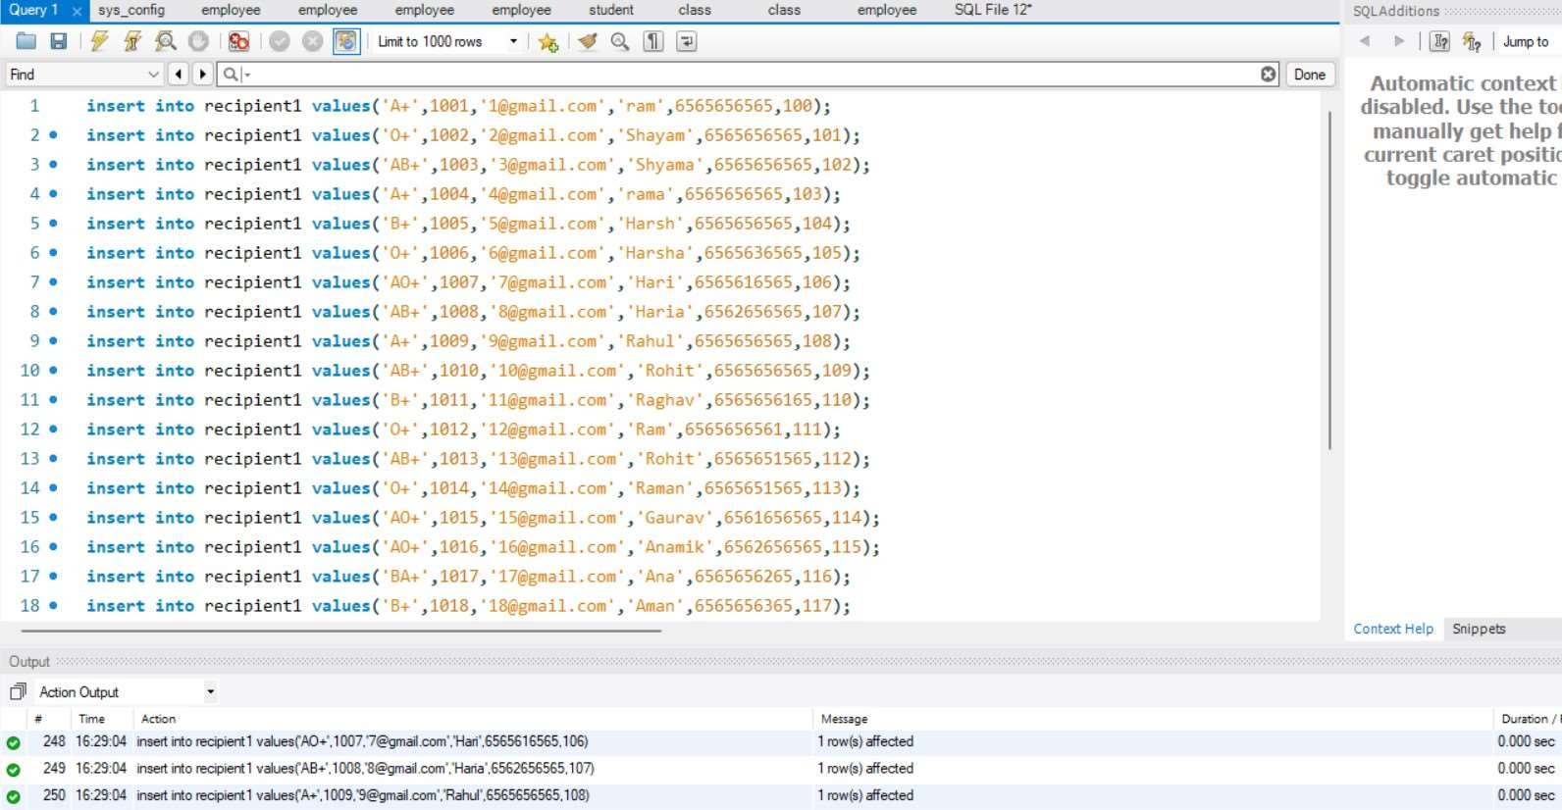

# SQL/PLSQL

QUERIES

1.FIND THE NAME OF DONOR FOR RECIPENT WHO RECEIVED BLOOD FROM UID 10!

select name from donor where uid in ( select uid1 from request where uid2 in ( select uid from

recipient where uid=10))

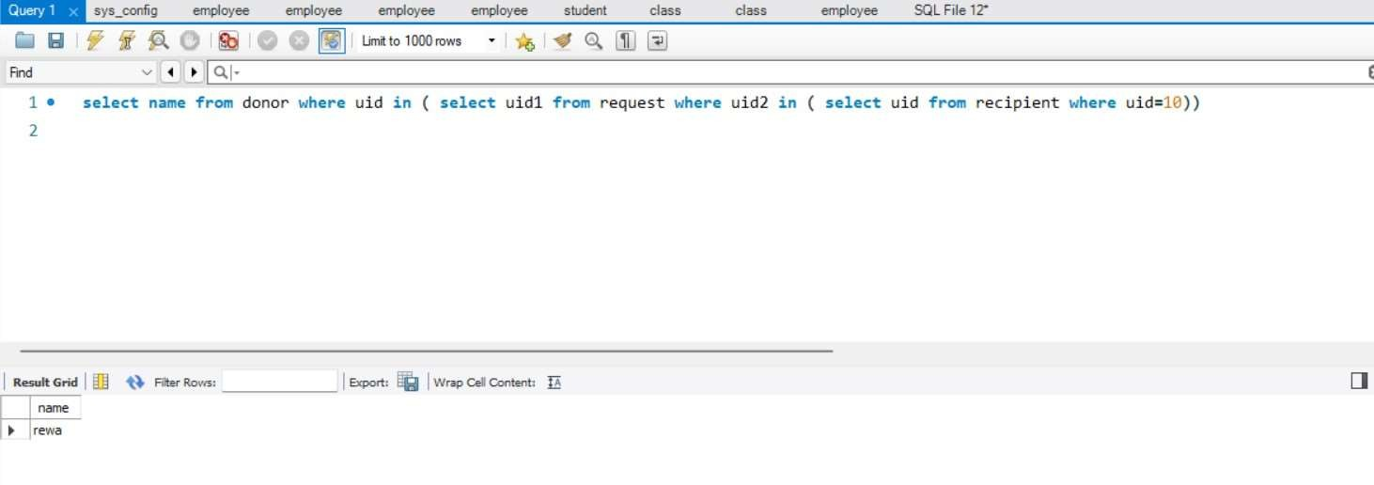

2.FIND THE NAME AND PHONE NUMBER OF DONOR FOR RECIPENT WHO RECEIVED BLOOD FROM UID 5!

select name,phone_no from donor where uid in ( select uid1 from request where uid2 in (

select uid from recipient where uid=5))

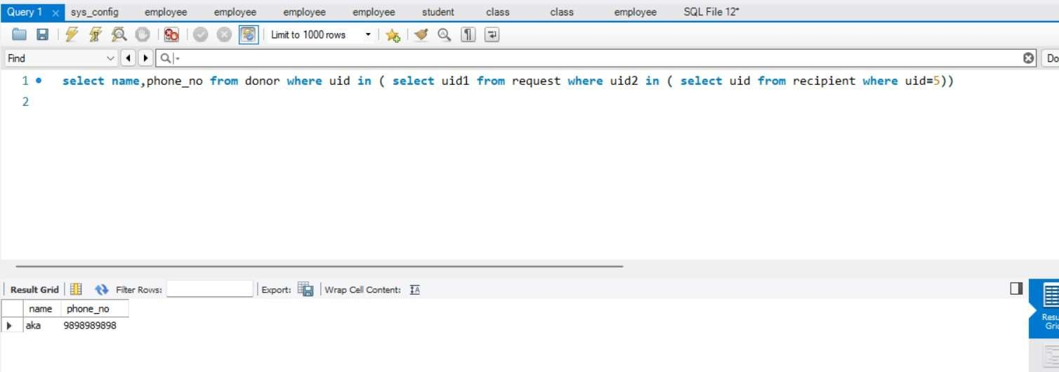

3.DISPLAY THE NAMES AND CONTACT OF THE PEOPLE WHO HAVE DONATED BLOOD IN PATIALA CITY.

SELECT name, phone_no from donation where oid1 in (select oid from organisation where city="Patiala");

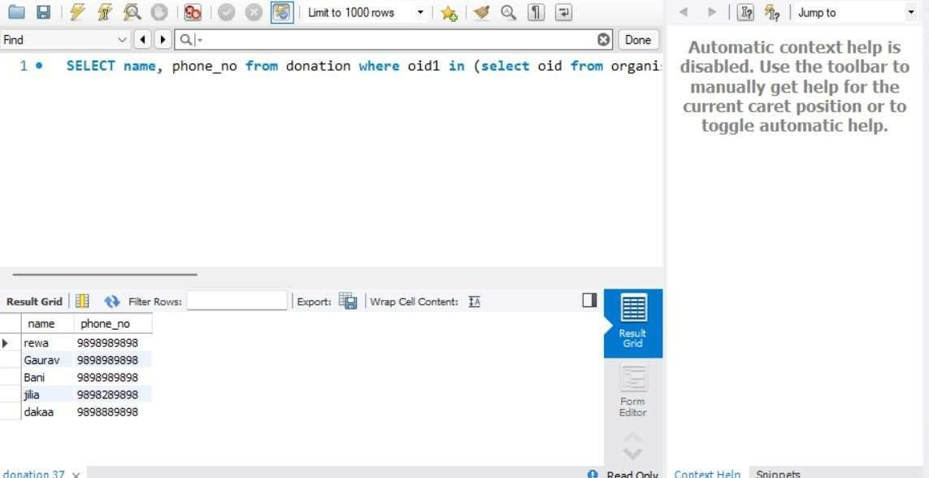

4.COUNT THE NUMBER OF DONATIONS IN AMRITSAR CITY

select count(*) from donation where oid1 in (select oid from organisation where

city="Amritsar")

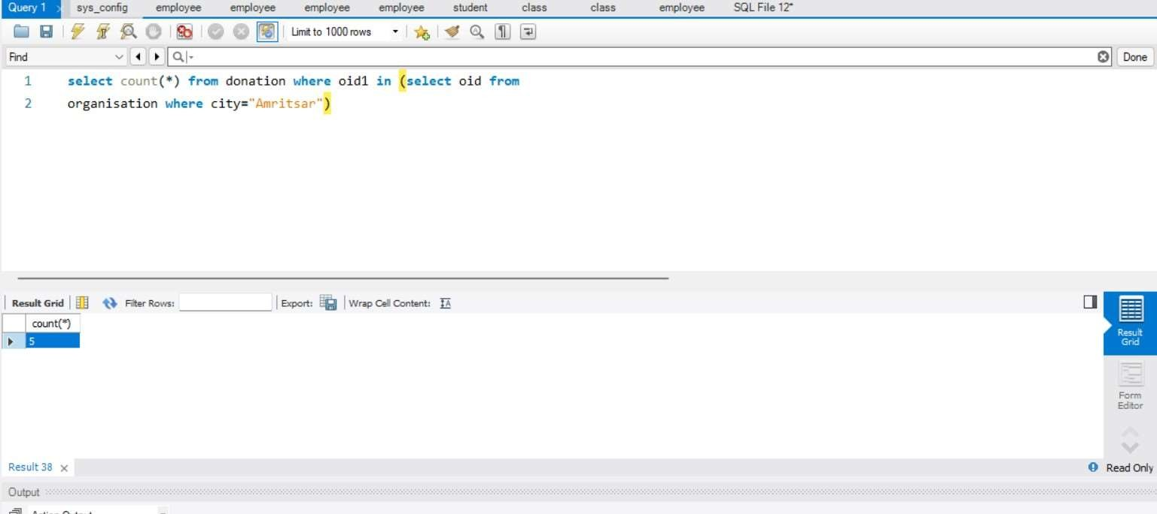

5.FIND TOTAL NUMBER OF CAMPS IN BHATINDA CITY

select count(name), o.city from organizes b , organisation o where o.city='Bhatinda';

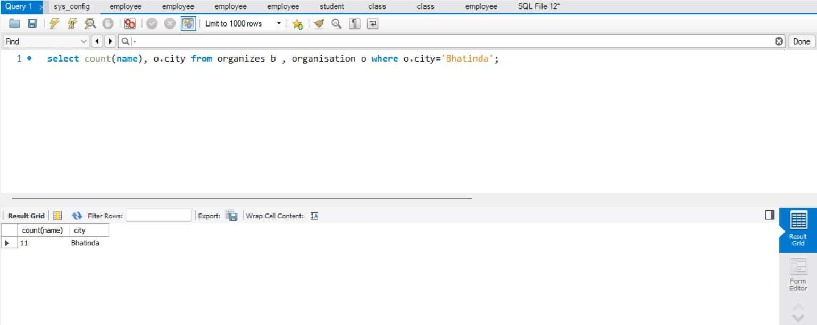

6.UPDATE PHONE NUMBER OF DONOR WITH ID 0001:

select name, phone_no from donor where uid=0001; update donor set phone_no = 9818814747 where uid=0001; select name, phone_no from donor where uid=0001;

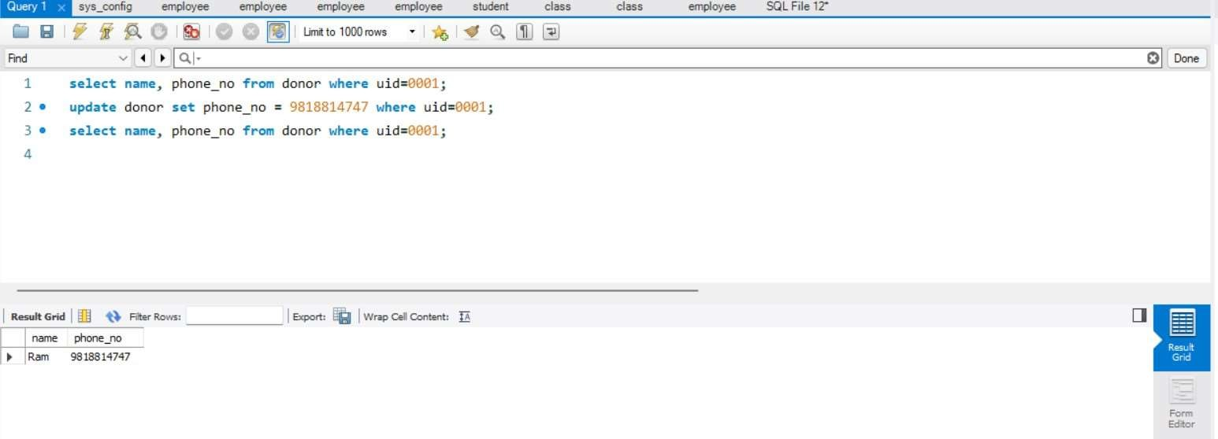

7.DISPLAY TOTAL NUMBER OF DONATIONS BLOOD GROUP WISE

select blood_group,count(certificate_id) from donation group by blood_group;

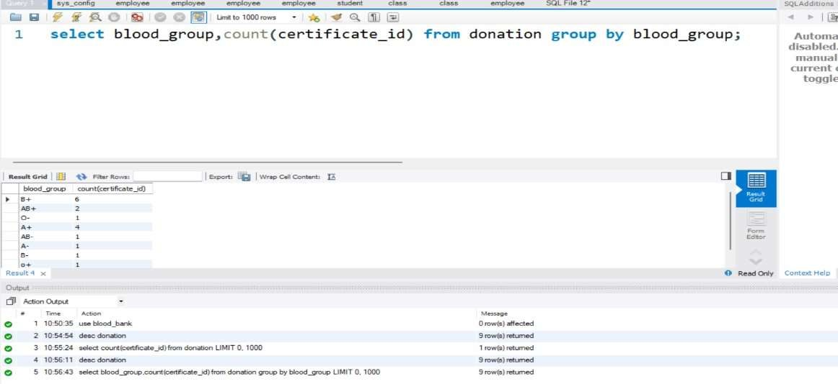

8.DISPLAY TOTAL AMOUNT OF B+ BLOOD COLLECTRRD FROM PATIALA CITY BY ANY ORGANISATION/CAMP.

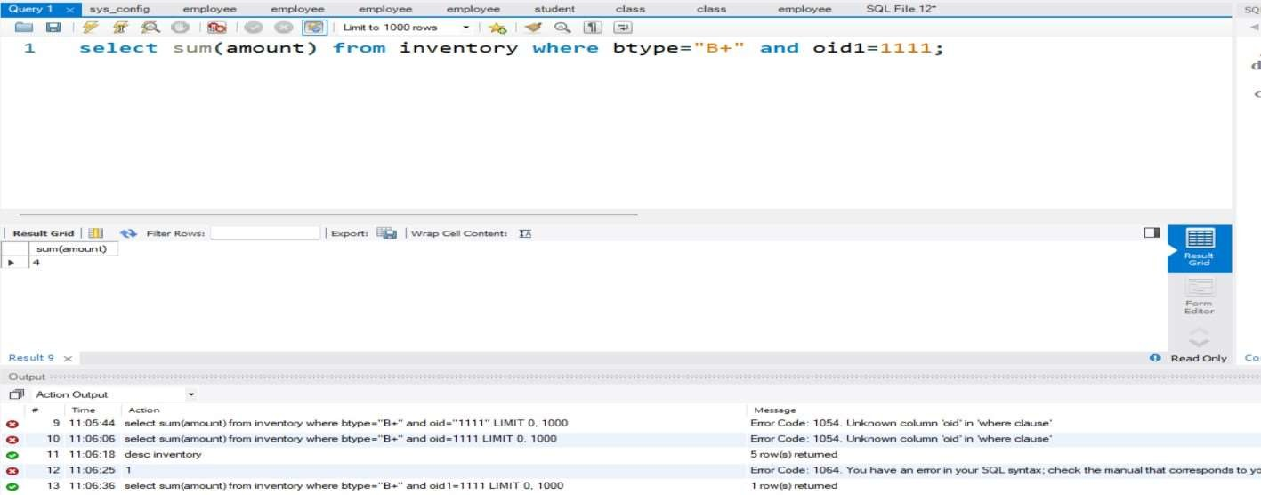

9.DISPLAY ALL BLOOD SAMPLES COLLECTED IN 5TH MONTH IN THE INVENTORY

SELECT * FROM inventory where date1>"2021-05-00" and date1<"2021-05-31";

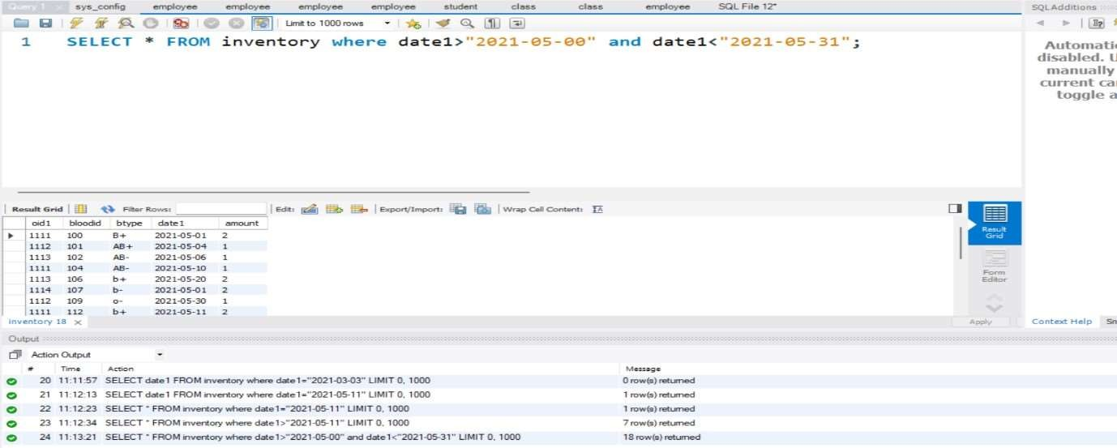

10.DISPLAY COUNT OF TOTAL SAMPLES CITY WISE.

select oid1, count(amount) from inventory group by oid1;

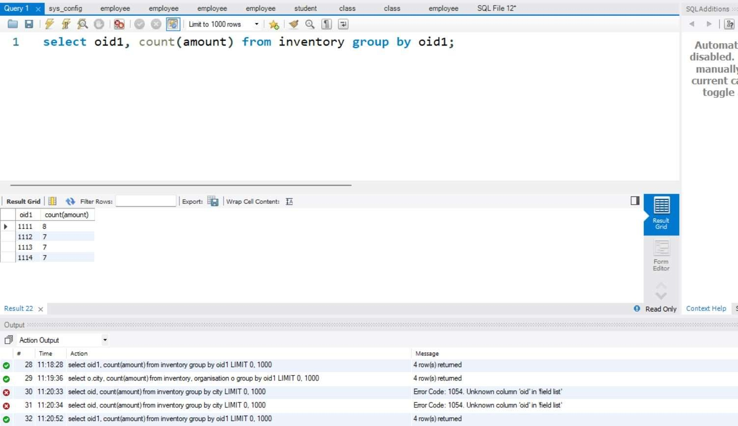

PLSQL

1.Write a code to check whether a given blood sample is in stock and if yes display to user else raise an exception.

declare ab blood.btype%type; begin select btype into ab from blood where bloodid=110;

dbms_output.put_line('AMPLE FOUND IN STOCK AND THE REQUESTED BLOOD SAMPLE IS '||ab); exception when too_many_rows then dbms_output.put_line('query returned more than one record'); end;

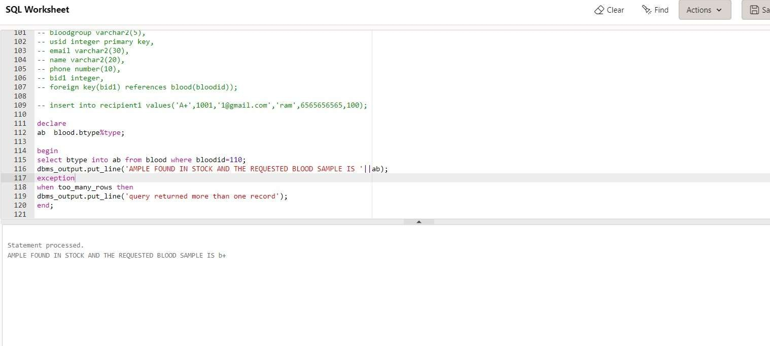

2.WRITE A CODE TO CHECK IF THE USER HAS ENTERED VALUES ACCORDING TO THE CORRECT DATA TYPE

begin insert into donor values(0090,'mridul','9118959898A','mridul@gmailcom','20010111','xyzafc','C+');

exception

when invalid_number then

dbms_output.put_line(' Conversion of string to number failed ');

end;

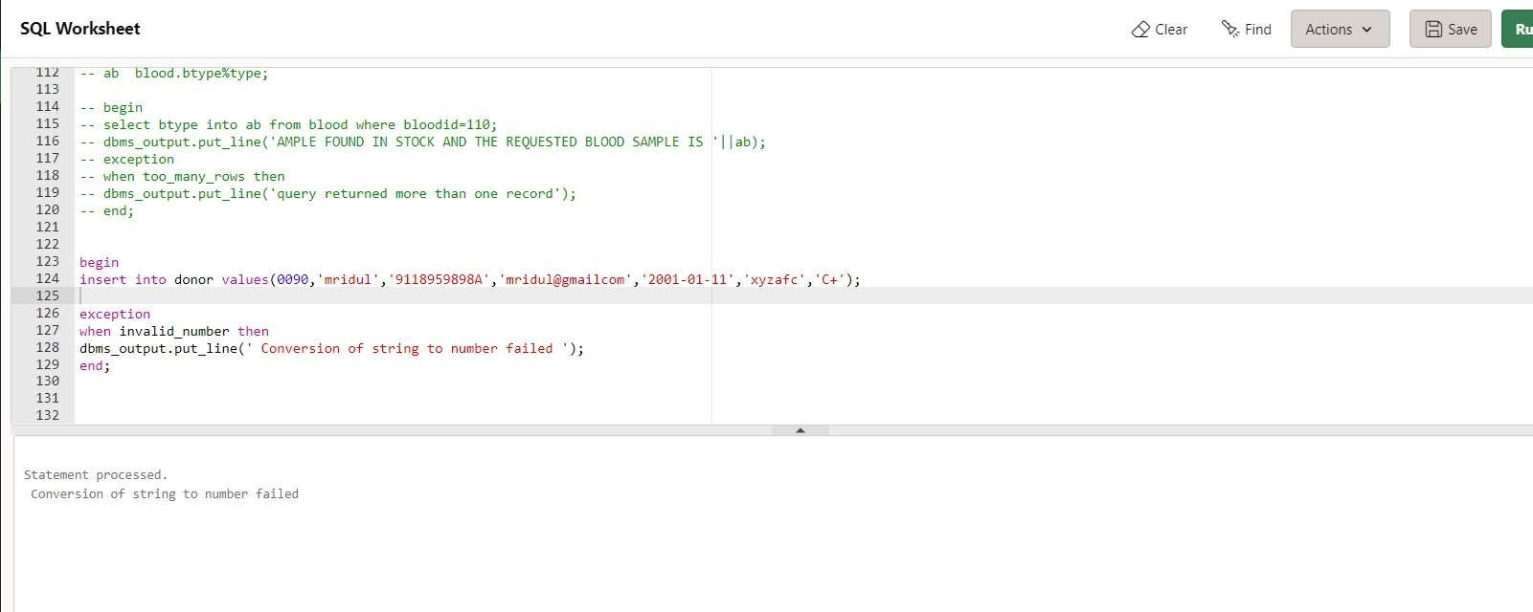

USING CURSOR:

3.UPDATE THE DONOR DATA BUT FIRST CHECK IF THE DONOR EXISTES ELSE RAISE EXCEPTION

declare

total_rows number(2);

begin

update donor

set phone_no = 987456321124 where usid = 0014;

if sql%notfound then dbms_output.put_line(' NO SUCH DONOR FOUND ');

elsif sql%found then total_rows:=sql%rowcount;

dbms_output.put_line('rows affected

'||total_rows); end if; end;

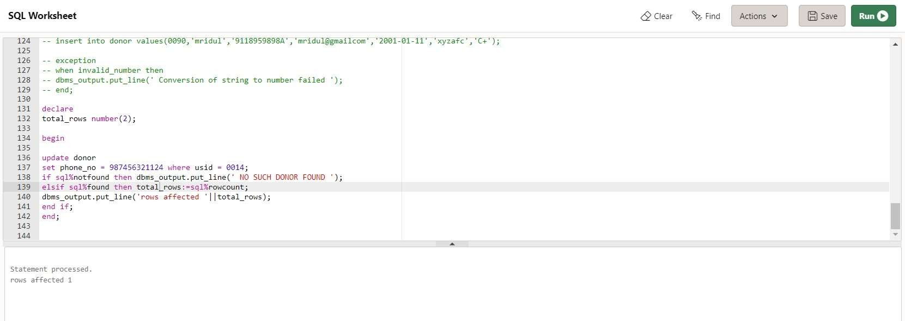

4.Write a procedure to return the people with a particular blood type and names starting from 'k' and 'r'

create or replace procedure blood_filter(b in varchar,n in varchar) is

bg donor.blood_group%type; np donor.name%type; id donor.usid%type; cursor cf is

select usid, name, blood_group from donor where blood_group==b and n LIKE 'r%' or n LIKE 'R%' or n LIKE 'k%' or n LIKE 'K%'; begin open cf; loop fetch cf into id,np,bg; exit when cf%notfound; dbms_output.put_line(np|| ' with id = ' ||

id || ' has blood group ' || bg); end loop; close cf; exception

when no_data_found then

dbms_output.put_line('Sorry no such products exist'); end;

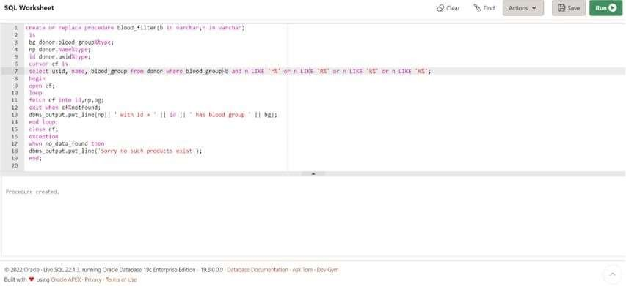

5.Write a procedure to check if there is an organisation in the given city else raise an exception

create or replace procedure org_details(c in varchar) is org_city varchar2(20); begin

select city into org_city from organisation where city = c; exception when no_data_found then

dbms_output.put_line('Sorry no such city exists !!'); end;

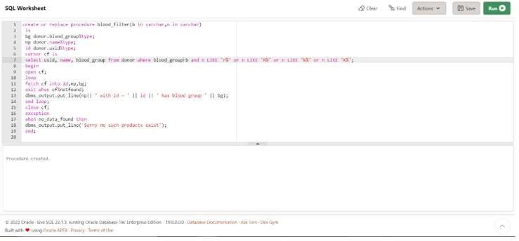

6.Write a procedure to check if there exists a certificate ID and its not duplicate

create or replace procedure certification(i in integer) is c_id integer; begin

select certificate_id into c_id from donation where certificate_id=i; exception when no_data_found then

dbms_output.put_line('Sorry no such certificate exists !!');

when too_many_rows then

dbms_output.put_line('Duplicate certificates exist'); end;

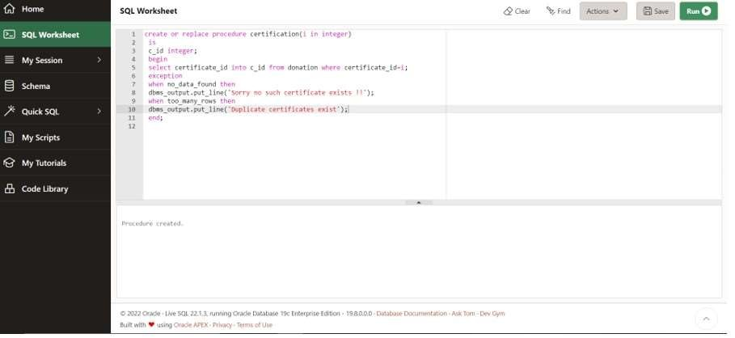

7.Trigger to count the number of distinct cities before inserting, deleting or updating anything in the organisation table

create or replace trigger org_donor before

insert or delete or update on organisation declare count1 number(3); begin select count( distinct state) into count1 from organisation; dbms_output.put_line(count1);

end;

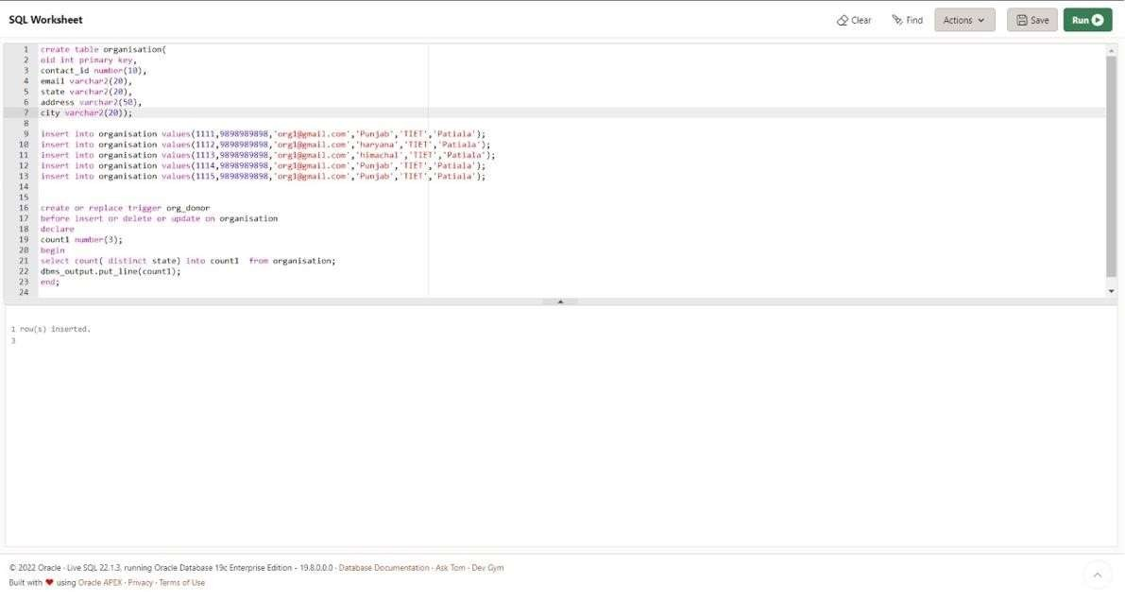

8.Trigger to count the number of donors before adding new donors

create or replace trigger count_donor before insert or delete or update on donor for each row declare count1 number(3); begin select count(*) into count1 from donor; dbms_output.put_line(count1); end;

